Score Sheet: Research Document

- Your presentation should contain all the content on the score sheet and your presentation slides should be in the same order as the score sheet.
  - Observation, Background Information, Research Question, Hypotheses, Variables, Procedures, & References will be scored by CRA (total of 34 points).
  - To pass you will need to receive at least 28 out of 34 points AND have been approved.
  - Title, Results, Data Analysis, Conclusion, & Presentation Skills will be scored at Symposium (total of 22 points).
  - To pass you will need to receive at least 18 out of 22 points.
CONTENT |  | 0 or 1 |  | COMMENTS
Title  3 pts | Title was a complete statement/question
 | Title matched the research question
 | Title clearly defined the purpose of the project
Observation  3 pts  1st Deadline | Observation stated the project’s problem clearly
 | Observation included why this project was important to the community
 | Observation included why this project was important to me
Justification/ Background Research  5 pts  2nd Deadline | Background information was related to the research question
 | Background information was referenced using correct in-text APA citations for all four sources
 | Background information had at least two facts from each source totaling at least 8 facts
 | Background information was highlighted (in bulleted format), not in paragraph form
 | Background information was not plagiarized
Research Question  4 pts  1st Deadline | Research question was a focused and specific question
 | Research question was researchable
 | Research question was measurable
 | Research question slide included a sentence explaining how addressing this research question will improve the community
Hypotheses  4 pts  1st Deadline | Hypothesis was based on research question
 | Hypothesis stated how the independent variable will affect the dependent variable.
 | Hypothesis slide included background information that helps explain the hypothesis
 | Null Hypothesis was stated correctly
Variables  4 pts  2nd Deadline | Correct independent variable
 | Correct dependent variable
 | Correct control variable (if needed)
 | Correct constant variables
Procedures  11 pts  3rd Deadline | See Project Type Chart Below
Results  5 pts | Results displayed data that matched research question.
 | Results included descriptive statistics in a chart (averages, percentages, etc.)
 | Results displayed pictorial evidence of research study (photos)
 | Results included charts/graphs that were properly labeled (title, key, x-axis, y-axis)
 | Results including graphs and charts were explained well
Data Analysis  3 pts | Data analysis included a statistical test used to test the hypothesis
 | Data analysis included an explanation of why that statistical test was used.
 | Data analysis included an explanation of the statistical significance of statistical test
Conclusion  5 pts | Conclusion included an accurate summary of the project
 | Conclusion interpreted the data to conclude if the data supported/rejected hypothesis
 | Conclusion answered the research question
 | Conclusion discussed limitations
 | Conclusion discussed how student(s) would implement change and/or bring awareness to their community
References  3 pts  2nd Deadline | Reference slide included 4 or more academic sources
 | Reference slide had ONLY in-text citations that were included as full references.
 | References were in the correct APA format
Presentation Skills  6 pts | Student(s) spoke clearly during the presentation
 | Student(s) could answer questions with confidence
 | Student(s) didn’t read slides word for word (used presentation and/or note cards for support)
 | Presentation had limited spelling/grammar errors
 | Presentation’s background (color/animation) was not distracting
 | Presentation’s text size/font were consistent
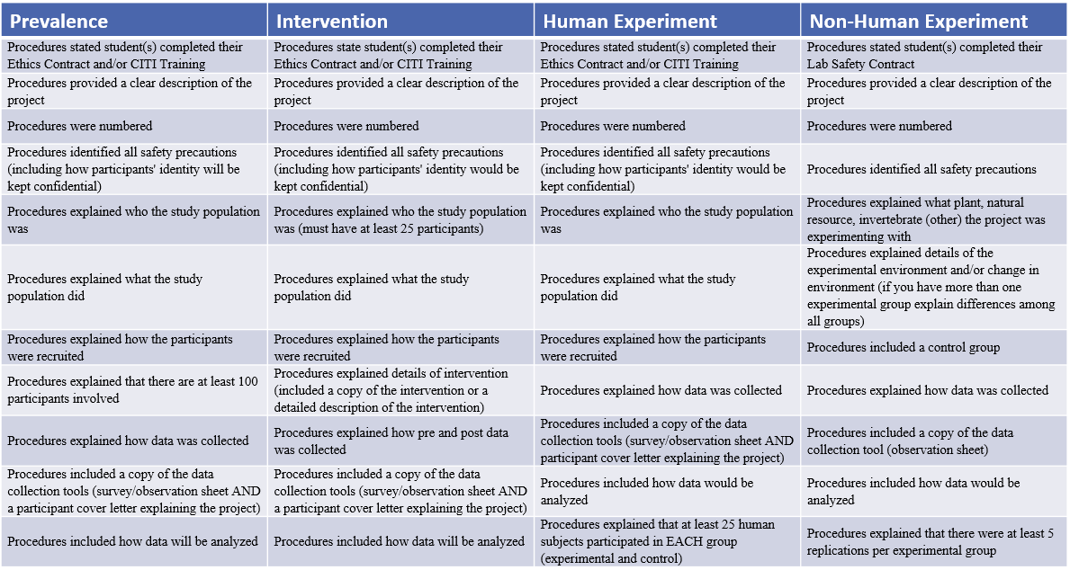
Project Type Chart

