Teacher Travel Handout
If you are able to log-in to your HSC e-mail account skip to Step 2
- Go to login.wvu.edu
If you have never logged into your HSC account, click “Claim Account”
If you have logged in before, click “Forgot Password” or “Reset Account”
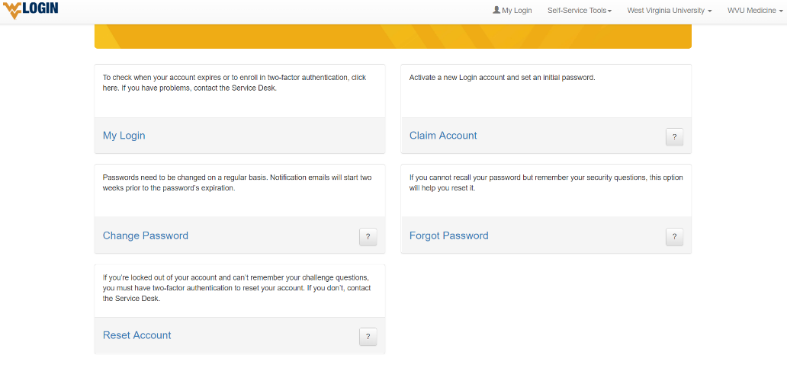

You may need to download the Duo Mobile app for two-factor authentication. It is free and sends you notifications to approve your login. You can also use a code on the app to login.
Follow the instructions to ensure that you are able to log-in to your HSC account.
If you need help please call the help desk 304-293-4444.
- Go to portal.wvu.edu
Login using your HSC account.
Scroll down. On the left you will see “Administrative Tools.” Click on “My Expenses”
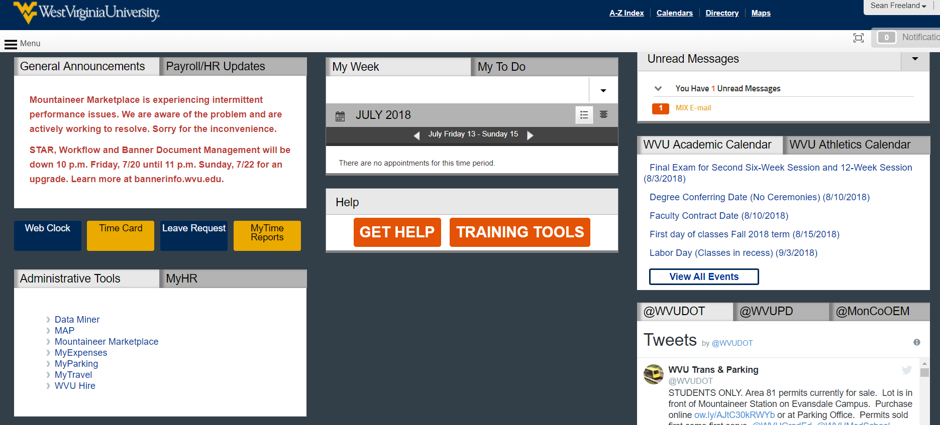
This will take you to Chrome River. Jill will enter your travel for camp for you. You will need to enter Chrome River to approve it.
- In Chrome River, do the following:
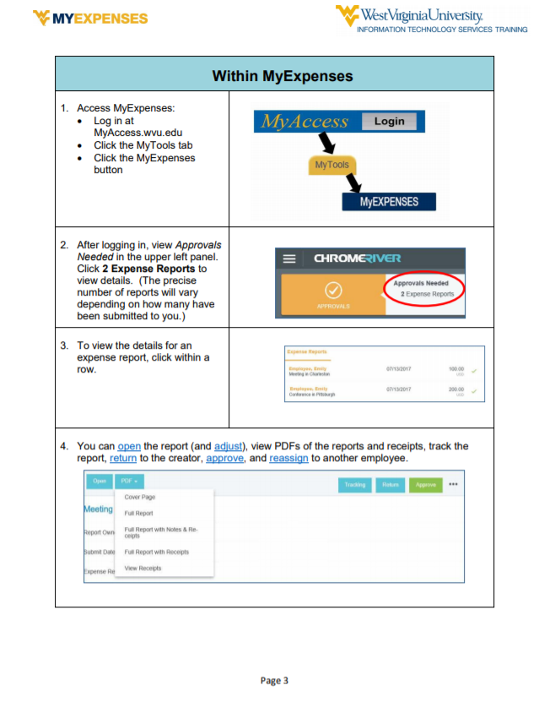
Click Open and review the info on the cover page, paying close attention to the address (which should be the traveler’s home address) and the departure and return dates (which should be the first and last dates of travel).

View each line submitted within the request for accuracy.

If anything is incorrect or any expenses are missing, click Return and enter an explanation. Otherwise, click Submit.

If you have questions, please contact Jill Simmons at jssimmons@hsc.wvu.edu or 304-374-6803.

