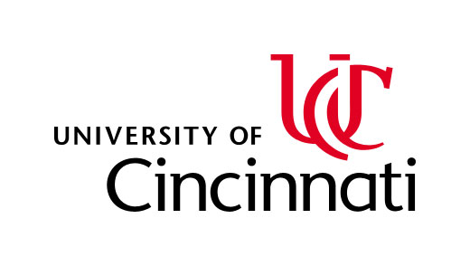 **SURF**

***SURF***

**Summer Undergraduate Research Fellowships**

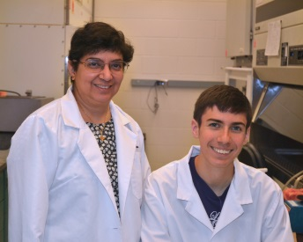

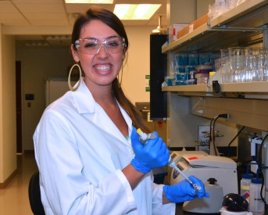

Experience the career of a biomedical researcher at one of two adjacent world-class research institutions: University of Cincinnati College of Medicine (UC COM) or Cincinnati Children’s Hospital Medical Center (CCHMC).

* Participate in a paid 10-week fulltime biomedical research project from starting the day after Memorial Day.
* Work with a faculty advisor assigned based on mutual research interest
* Attend social and scientific events and our Professional Development Series
* Present your work at the Capstone Poster Symposium

Applications are accepted from Nov 1st through Feb 1st at <http://med.uc.edu/SURF>

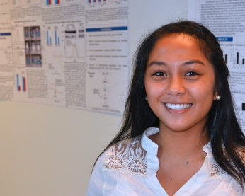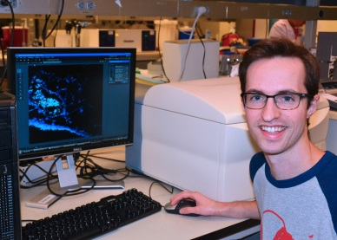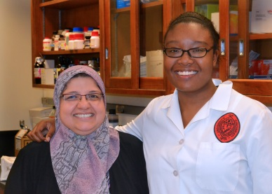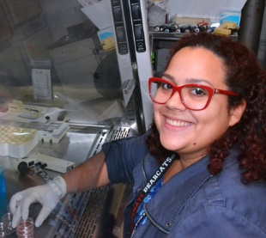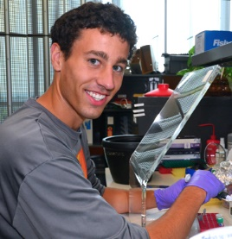

UC COM and CCHMC feature ongoing research in nearly all areas of biomedical investigation.

Major research focus areas include:

* Cardiovascular and pulmonary disease
* Cancer and blood diseases
* Developmental disorders
* Immunobiology and infectious diseases
* Metabolic disorders
* Neuroscience, neurodegenerative disorders and psychology
* Bioinformatics and Big Data

**2021 SURF Programs Include:**

GE Graduate Education (College of Med)

CCHMC Cincinnati Children’s Hospital Med Center

BMI Biomedical Informatics Fellowship

Neuro Neuroscience Fellowship

ASPET American Society of Pharmacology and Experimental Therapeutics Fellowship

HEART American Heart Associate Fellowship

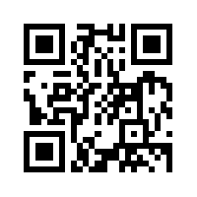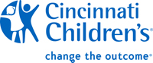

*For more information, contact:* [comGradEd@ucmail.uc.edu](mailto:comGradEd@ucmail.uc.edu) *or visit the QR code:*

