**Activity #8**

**Name:**

**High School:**

**HSTA Teacher:**

### #8 Handout

For Questions 1-7, use the letters in the pedigree chart shown below. Some of the labels may be used more than once.

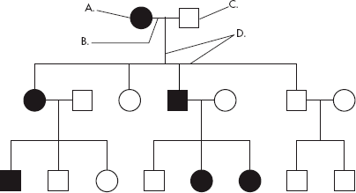

________ 1. A male

2. A female

________ 3. A marriage

_________4. A person who expresses the trait

_________5. A person who does not express the trait

_________6. A connection between parents and offspring

________ 7. How many generations are shown on this chart?

**Hemophilia Defined:** a medical condition in which the ability of the blood to clot is severely reduced, causing the sufferer to bleed severely from even a slight injury. The condition is typically caused by a hereditary lack of a coagulation factor, most often factor VIII.

**Hemophilia Explained Video:** [**https://www.youtube.com/watch?v=BoXBuJSURTI**](https://www.youtube.com/watch?v=BoXBuJSURTI)

**Use the pedigree below to answer 8-12**



8. In a pedigree, a square represents a male. If it is darkened, he has hemophilia; if clear, he had normal blood clotting.

a. How many males are there? __________________

b. How many males have hemophilia? ____________

9. A circle represents a female. If it is darkened, she has hemophilia; if open she is normal.

a. How many females are there? _________________

b. How many females have hemophilia? __________

10. A marriage is indicated by a horizontal line connecting a circle to a square.

a. How many marriages are there? _______________

11. A line perpendicular to a marriage line indicates the offspring. If the line ends with either a circle or a square, the couple had only one child. However, if the line is connected to another horizontal line, then several children were produced, each indicated by a short vertical line connected to the horizontal line. The first child born appears to the left and the last born to the right.

a. How many children did the first couple (couple in row I) have? ______________

b. How many children did the third couple (couple in row III) have? ____________

12. Level I represent the first generation; level II represents the second generation.

a. How many generations are there? _______________

b. How many members are there in the fourth generation? _____________

**Use the pedigree below to answer 13-18.**

**Huntington’s Disease Defined:** a hereditary disease marked by degeneration of the brain cells and causing chorea and progressive dementia.

**Chorea Defined**: a neurological disorder characterized by jerky involuntary movements affecting especially the shoulders, hips, and face

**Huntington’s Disease Explained Video:** [**https://www.youtube.com/watch?v=JL9Y3P870jU**](https://www.youtube.com/watch?v=JL9Y3P870jU)

**Shaded Individuals Have Huntington’s Disease**



13.Write the generation on the pedigree numbers (roman numerals).

14.Which members of the family above are afflicted with Huntington’s Disease?

15.There are no carriers for Huntington’s Disease- you either have it or you don’t. With this in mind, is Huntington’s disease caused by a dominant or recessive trait?

16.How many children did individuals I-1 and I-2 have?

17.How many girls did II-1 and II-2 have? How many have Huntington’s Disease?

18.How is individual III-2 and II-4 related? I-2 and III-5?

**Use the Pedigree below to answer 19-23**

**Hitchiker’s Thumb Explained: Hitchhiker's thumb** is a **thumb** that's hypermobile, or very flexible, and able to bend backward beyond the normal range of motion.

 

19. Write the generation on the pedigree numbers (roman numerals). The pedigree to the above shows the passing on of Hitchhiker’s Thumb in a family. Is this trait dominant or recessive?

20. How do you know?

21. How are individuals III-1 and III-2 related?

22. Name 2 individuals that have hitchhiker’s thumb.

23. Name 2 individuals that were carriers of hitchhiker’s thumb.

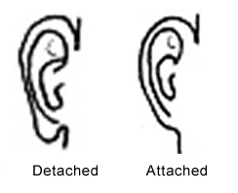**Now let’s look at some of your traits**

Earlobes:

If earlobes hang free, they are detached. If they attach directly to the side of the head, they are attached earlobes. Some scientists have reported that this trait is due to a single gene for which unattached earlobes is dominant and attached earlobes is recessive

24.

* 1. Do you have attached or detached earlobes?
  2. Based on the structure of your earlobes, what can you say about your parents’ genes?
  3. If possible, check out your parents and grandparents’ earlobes and make your own pedigree. (You can also ask your any aunts and uncles too.)

25.Tongue rolling:

Rolling the tongue (like shown in the picture) into a tube shape is often described as a dominant trait.

* 1. Can you roll your tongue?
  2. Based on whether or not you can roll your tongue, what can you say about your parents’ genes?
  3. If possible, ask your parents and grandparents’ if they can roll their tongue and make your own pedigree. (You can also ask your any aunts and uncles too.)

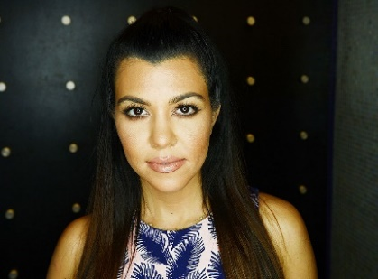26. Widow’s peak:

A pointed frontal hairline, popularly referred to as widow's peak, may be inherited as an autosomal dominant.

If you have bangs or hair on your forehead, you will need to pull the hair back to see your hairline.

* 1. Do you have a widow’s peak?
  2. Based on whether or not your parents have a widow’s peak, what can you say about your parents’ genes?
  3. If possible, ask your parents and grandparents’ if they have a widow’s peak and make your own pedigree. (You can also ask your any aunts and uncles too.)

For more information if you’re interested, here is a link to some other fun examples of how cool genetics can be! <https://www.koshland-science-museum.org/sites/default/files/uploaded-files/Inventory_of_Your_Traits.pdf>