Activity #12

Name:

High School:

HSTA Teacher:
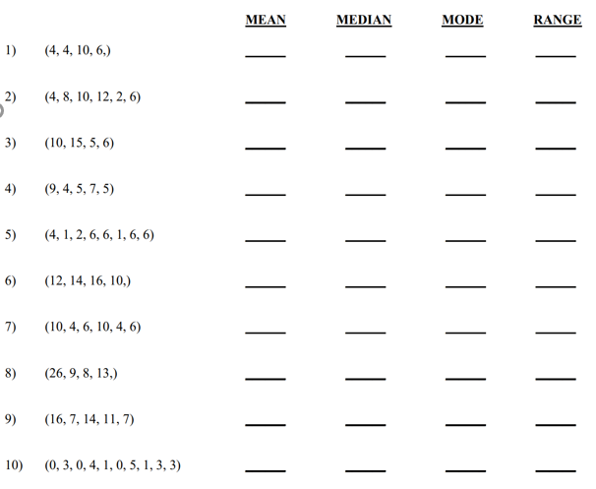

From Worksheet 3: http://imathworksheets.com/stats-probability/meanmedianmoderange-worksheets/

Finally, look at the data Becky collected.

Using a program like Excel, find the mean, median and mode for this data.
69 | 52 | 41 | 36 | 52
48 | 81 | 53 | 49 | 65
25 | 52 | 38 | 58 | 29
44 | 47 | 25 | 16 | 25
11 | 15 | 35 | 34 | 46
52 | 14 | 50 | 96 | 43

Mean =
Median =
Mode =

