Activity #17

Name:

High School:

HSTA Teacher:

Please go to the website: https://www.marshall.edu/hsta/virtual-fun-with-science-summer-2020/ and explore all the counties virtually from our Marshall University students’ point of view. Some of the experiences are listed below.

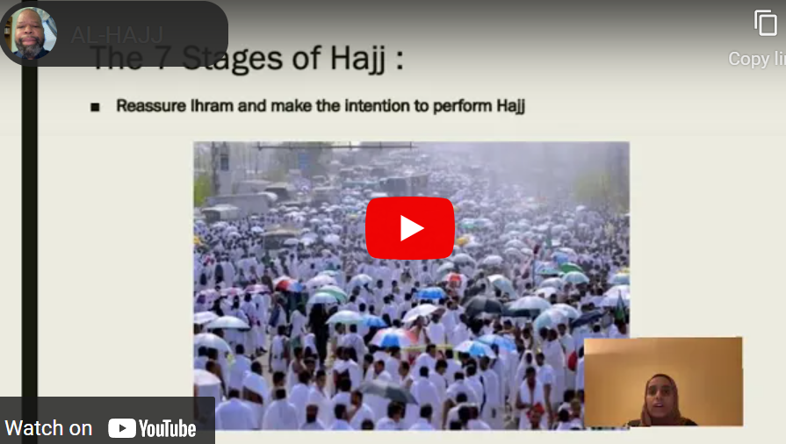 | 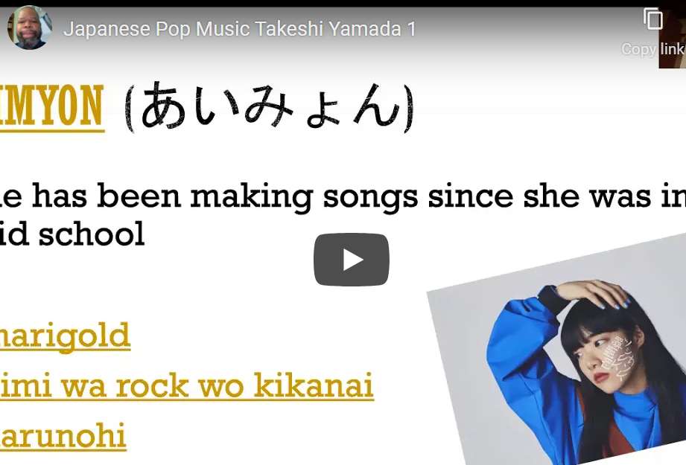
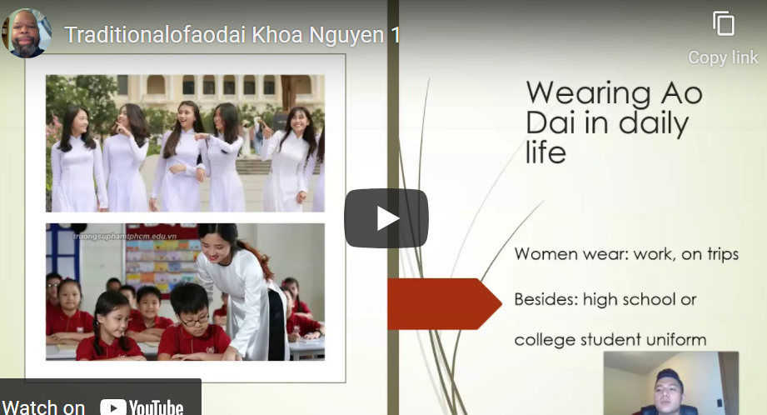 | 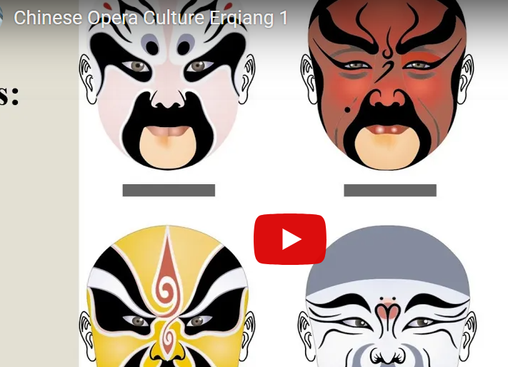

Watch at least two videos, submit 3-4 sentence summary.

