CITI Training Directions

CITI training is Collaborative Institutional Training Initiative or CITI. It is a college level ethics training that all researchers affiliated with a University or Institution must complete before beginning any research. It teaches why we must have training so that studies like Tuskegee, Willowbrook, or Nazi experiments never occur again. Everyone must complete the training during their freshmen year. This training is good for four years. Due December 1. Website: https://www.citiprogram.org/
- Google CITI Training Login – It will bring you to this page. If you don’t know/have a username and password, click on Register.
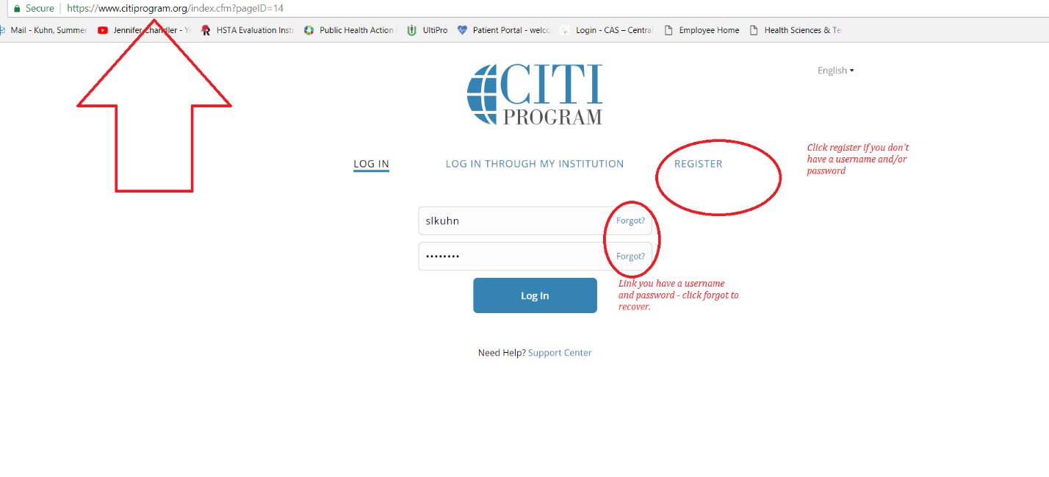
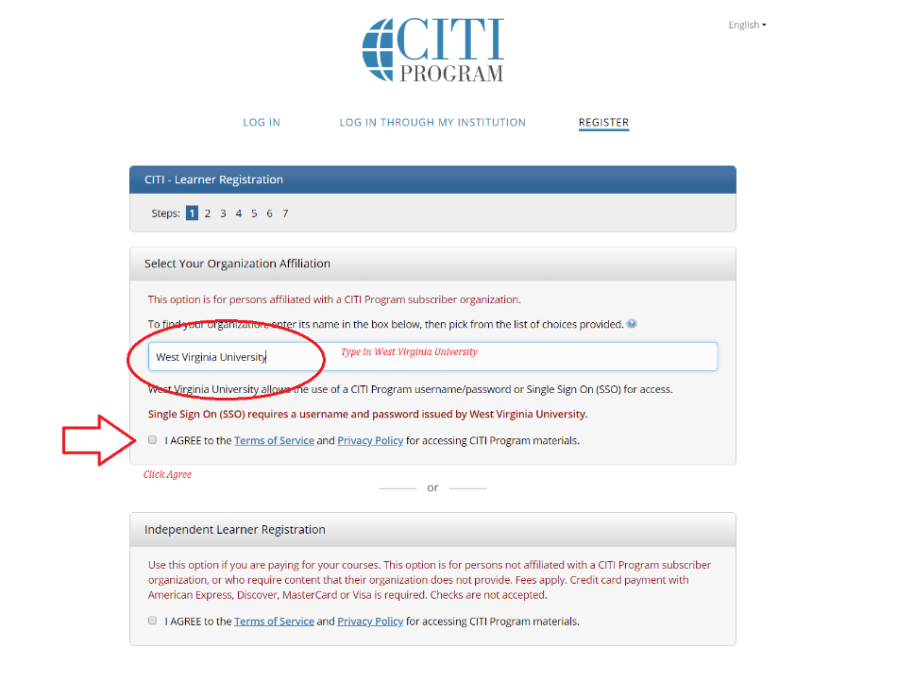
- Type in West Virginia University. Click I agree.

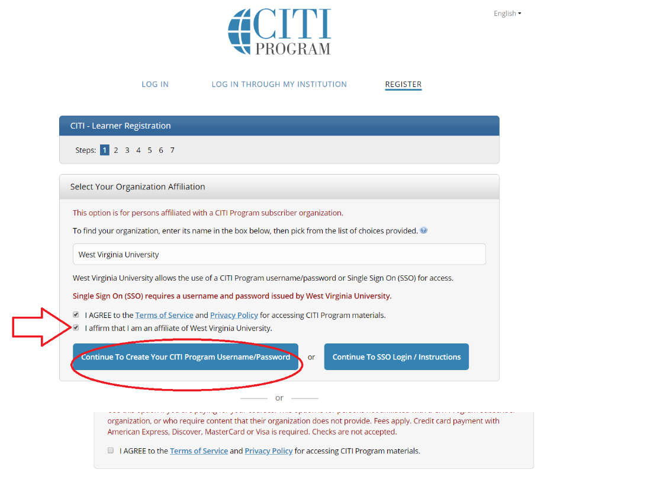
- Click on I affirm… Then the Continue to…

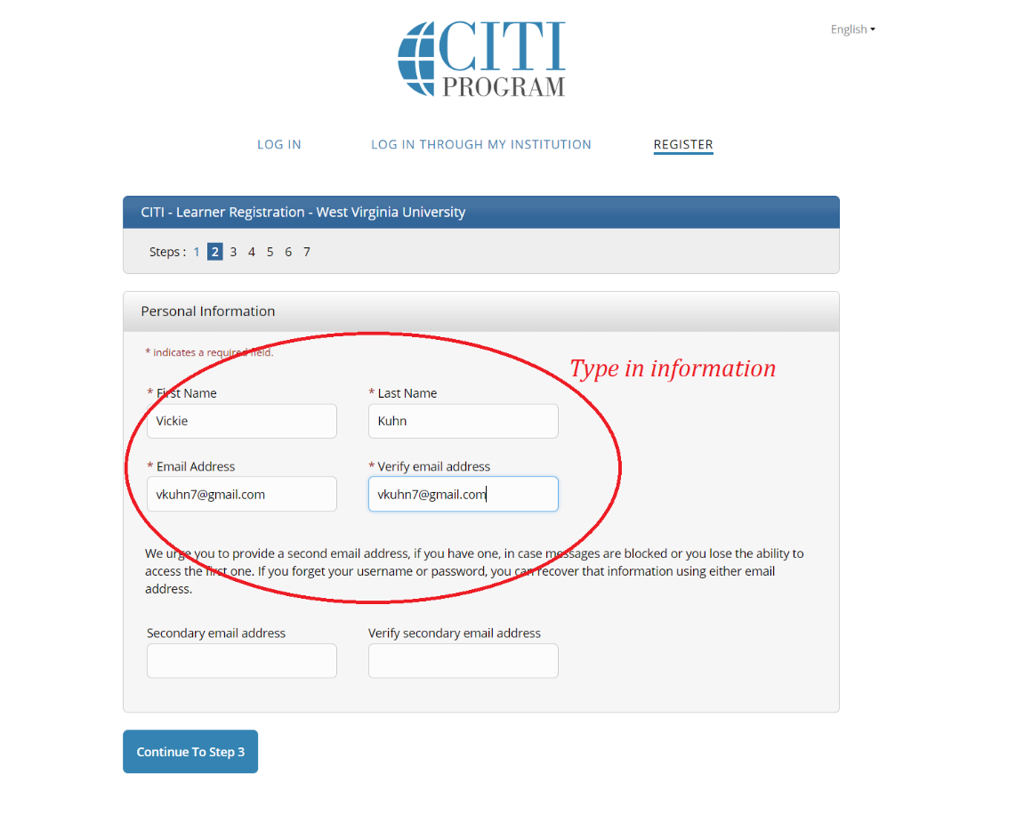
- Type in your information in the red circle, then click on Continue to Step 3

- Fill in all the information in the red circle. Click on to Step 4.
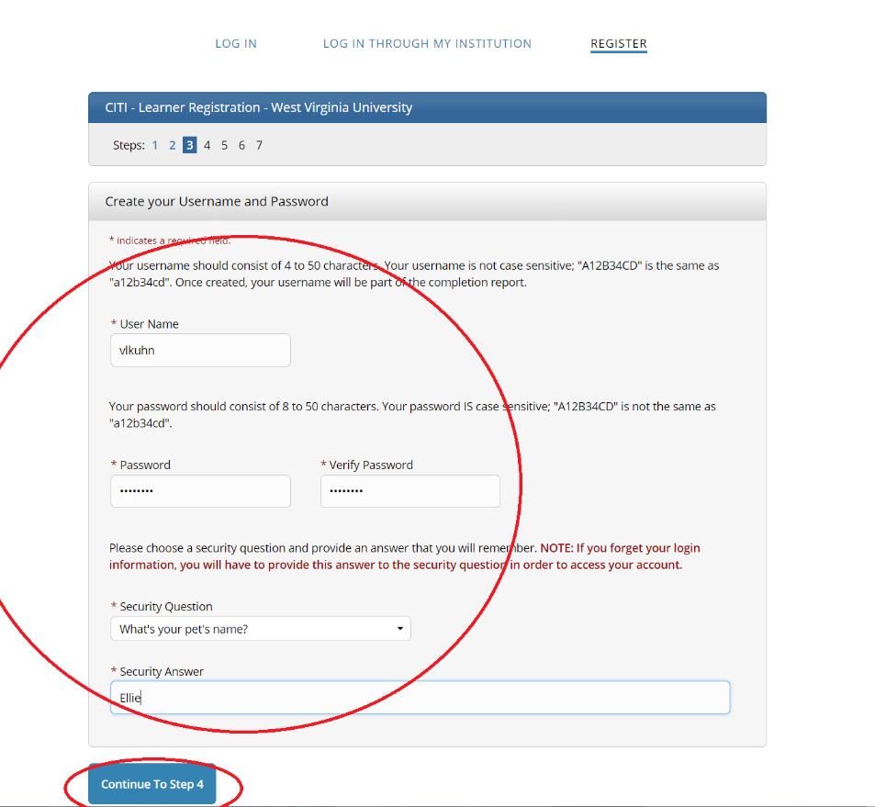

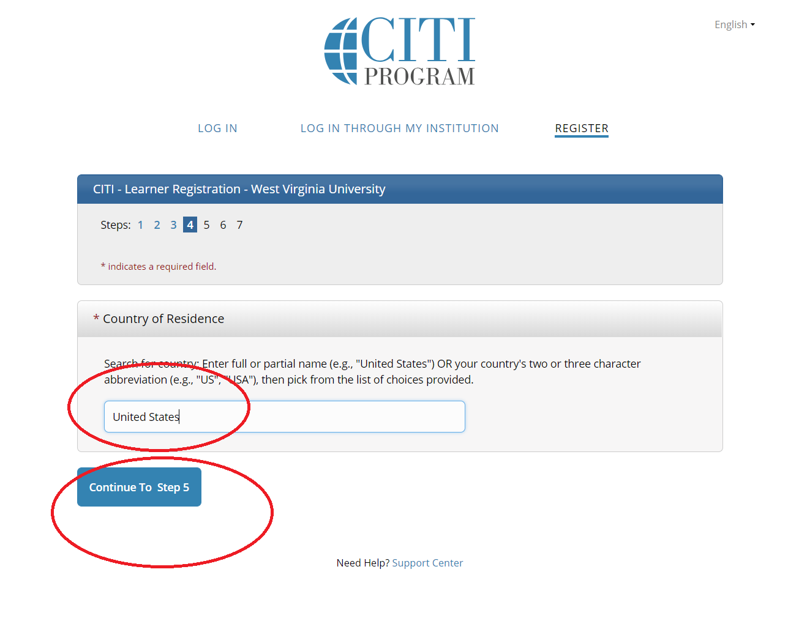
- Enter United States and Click to Step 5.

- Click No, Skip the next one, then answer the last two.
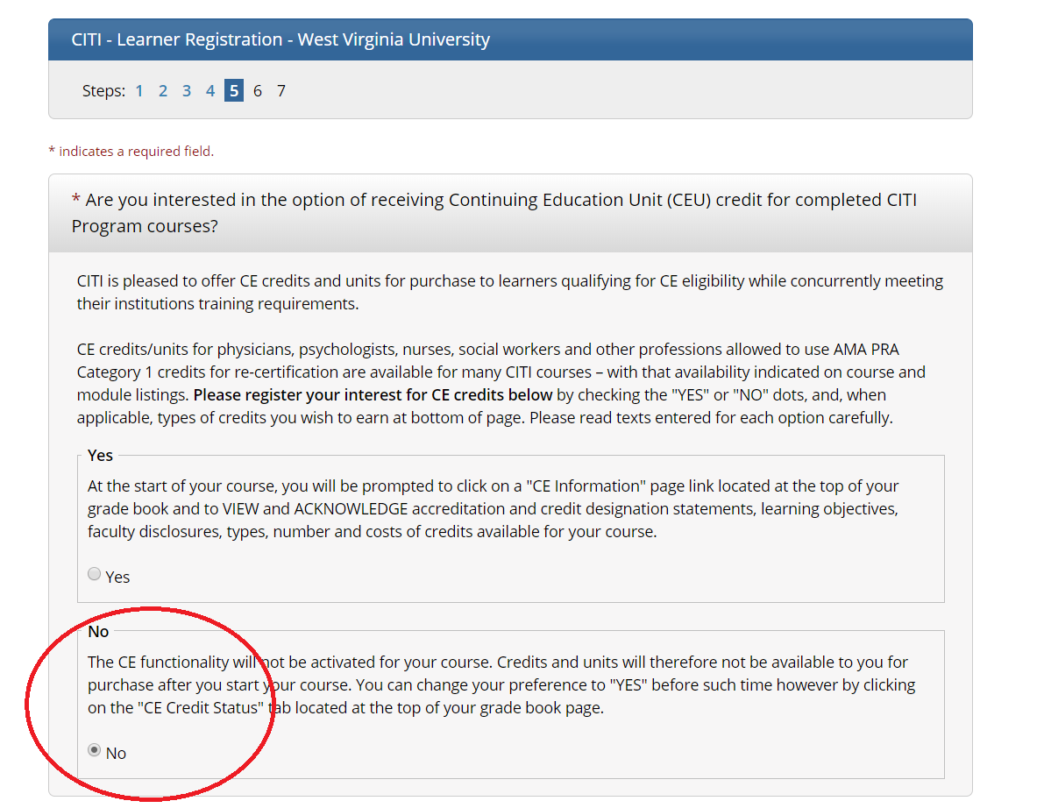
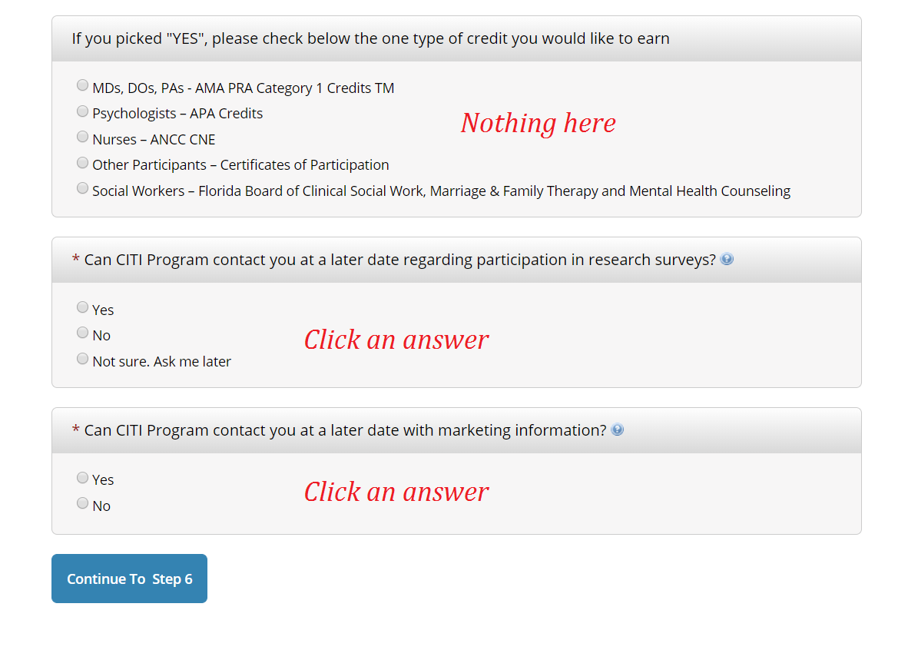

- Fill in everything in red. Then click on to Step 7.
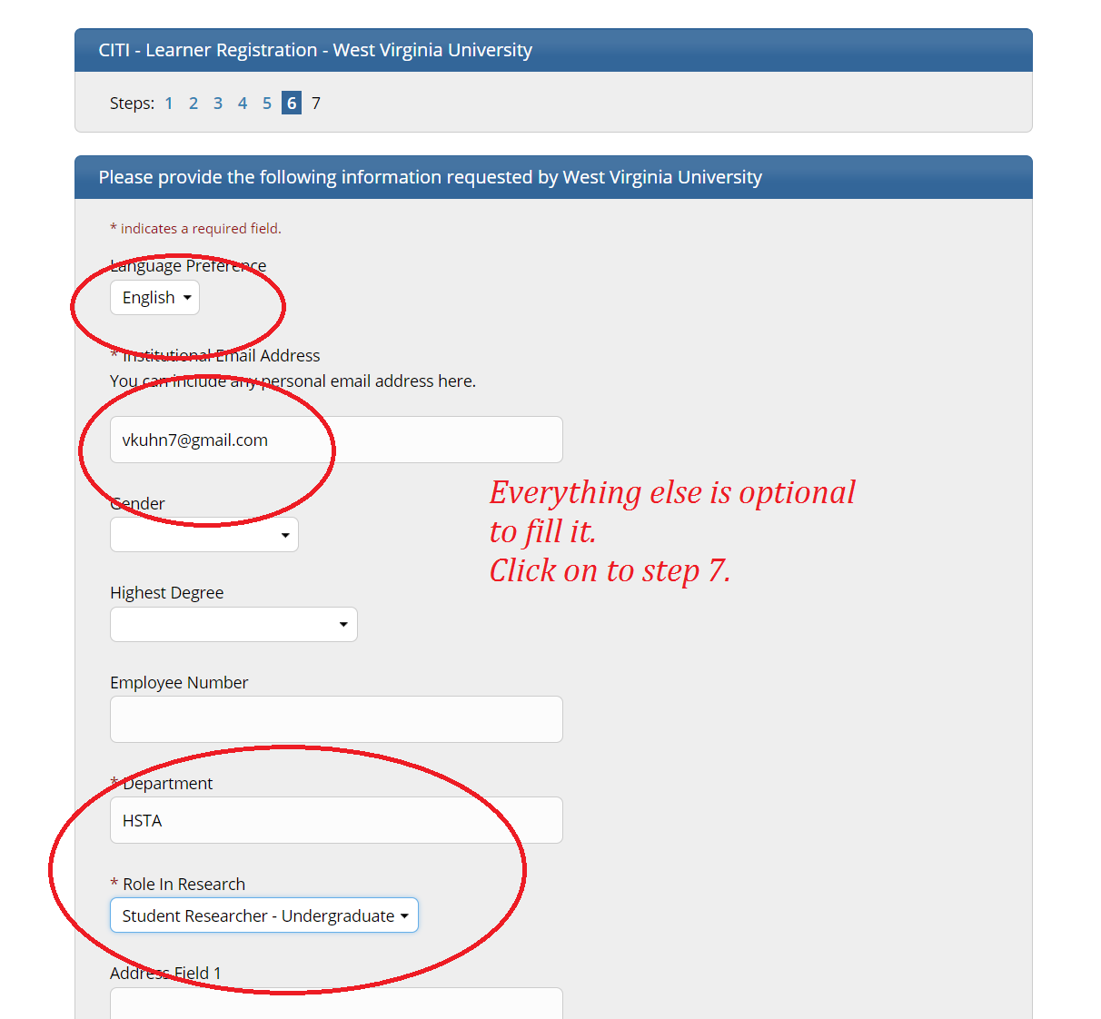

- There will be a list of questions. Click on the following courses:
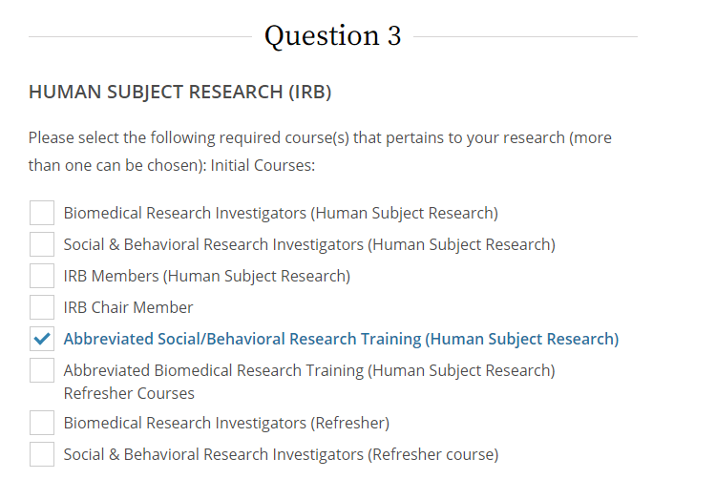
- Then scroll to the very bottom and click on Submit
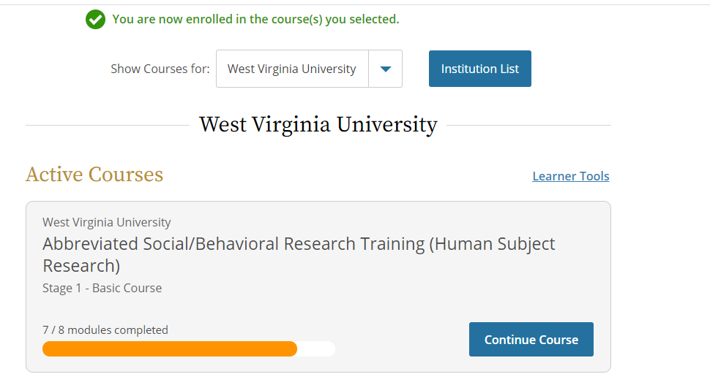

- Click the icon to start or continue your course.

- Click the down arrow on West Virginia University Courses. Then Click on each course to complete it.
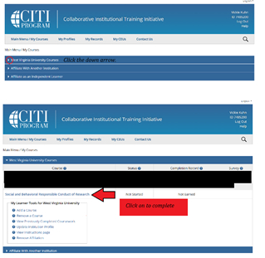

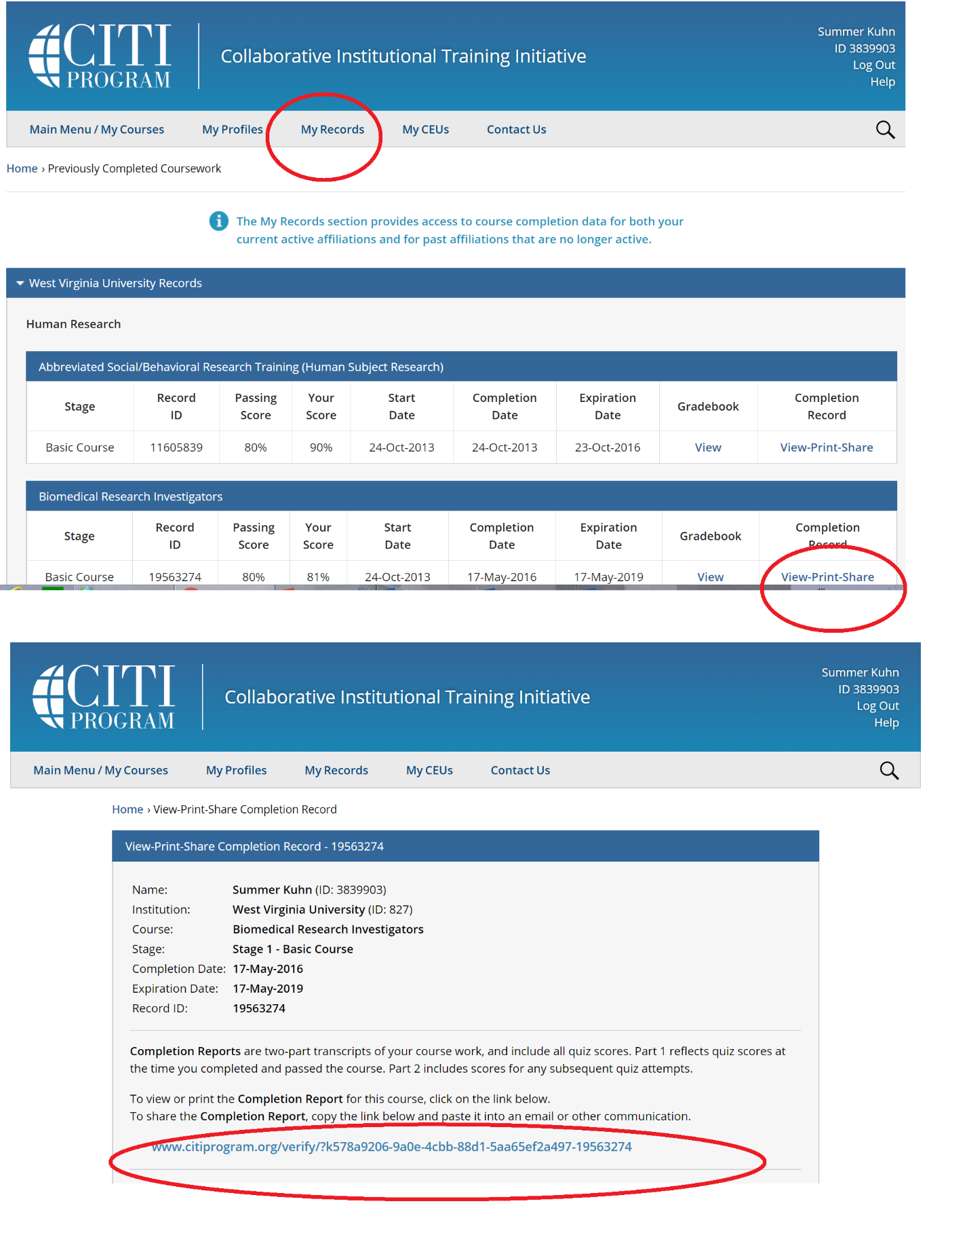

Email certificate your Field Site. Due December 1st.

- To add a course: You are on the Main Menu/My Courses. Click Add a Course. Then the Questions will pop up again.
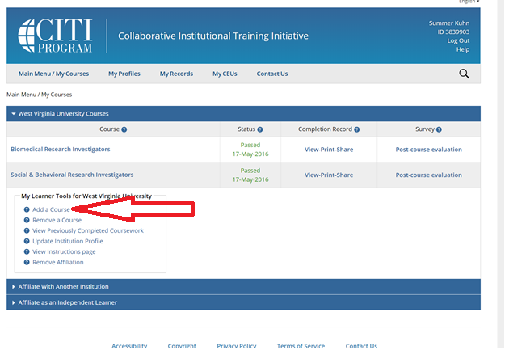
Click on:

