In order to use Share Point you have to access your HSC email/Office 365 online.
FSC Report
- All FSC reports will be moved to SharePoint due to technology concerns by WVU IT.
- I have deleted all seniors, moved up other students’ grade level. You will have to enter freshmen in the Aug/Sept tab in the teacher report and to the FSC report.
  - If you have a student who had been dismissed please don’t delete them in the FSC report.
  - This helps with keeping up with retention.
  - Please just color then RED and say dismissed and the reason, moved to REGION ETC in the behavior section under which semester.
  - If you have a Freshman who didn’t go to Summer Camp and/or no meetings they can be deleted. They will not be counted towards retention numbers as of now.
- FSC and teacher reports will not link since they are in two different locations. Futher directions on how to connect these reports will be emailed out.
- A document that discribes the way we enter data and/or data we collect will be created so that all reports are reporting the same way.
Teacher Report
- Teacher reports will still be located in Dropbox. I have deleted all seniors, moved up other students’ grade level. You/HSTA Teacher will have to enter freshmen in the Aug/Sept tab.
  - You can delete indivduals who have been dismissed but please email me to help with retention numbers.
- We will start to move teachers to SharePoint late Fall/Spring. We will do this one region at a time and will keep you in the loop.
- In order to use Share Point, HSTA teachers have to use their HSC emial accounts.
- Please review teacher reports and let me know if you have any questions.
SharePoint Directions.
1. An email will be sent inviting you to the Share Point Folder for your region. Please click on the invite and it should take you to the Share Point site.
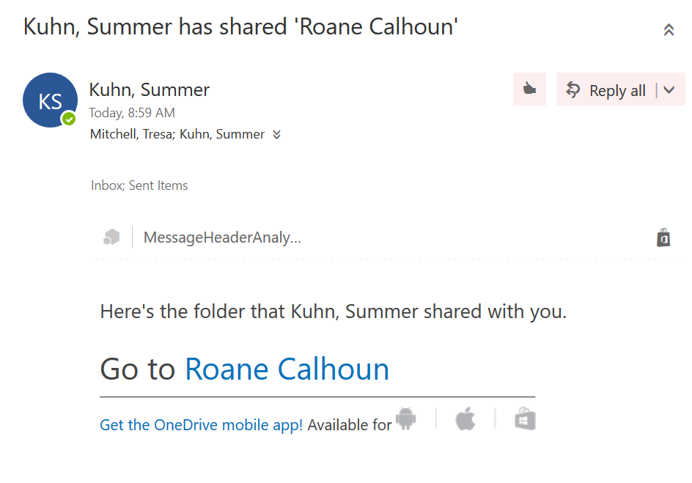

2. You can click on the App Square that will allow you to navigate Office 365.
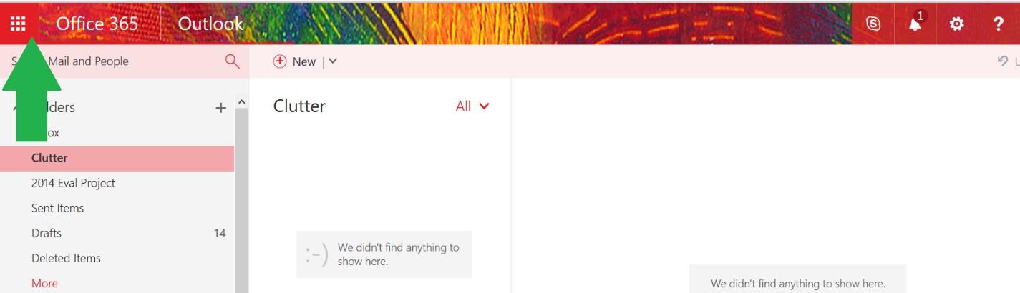

3. The App Square. Here you can go from Mail, Calendar, ETC. We will be using SharePoint for FSC and teacher reports. Side Note: OneDrive is a great place to store files – Works just like Dropbox, but you have to have the internet to connect to OneDrive. SharePoint is used to store files for a large group.
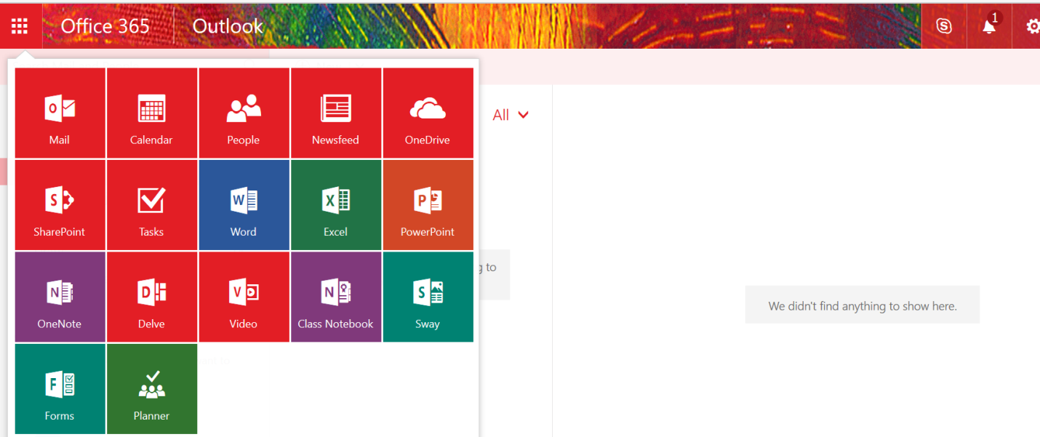

4. When you click on SharePoint your screen will look similar but not the same as the example below. Again you have the App Square where you can go back and forth between all Office 365 apps including Mail and Calendar. If you get this screen click on the HSTA site and it will bring up your region’s folder.
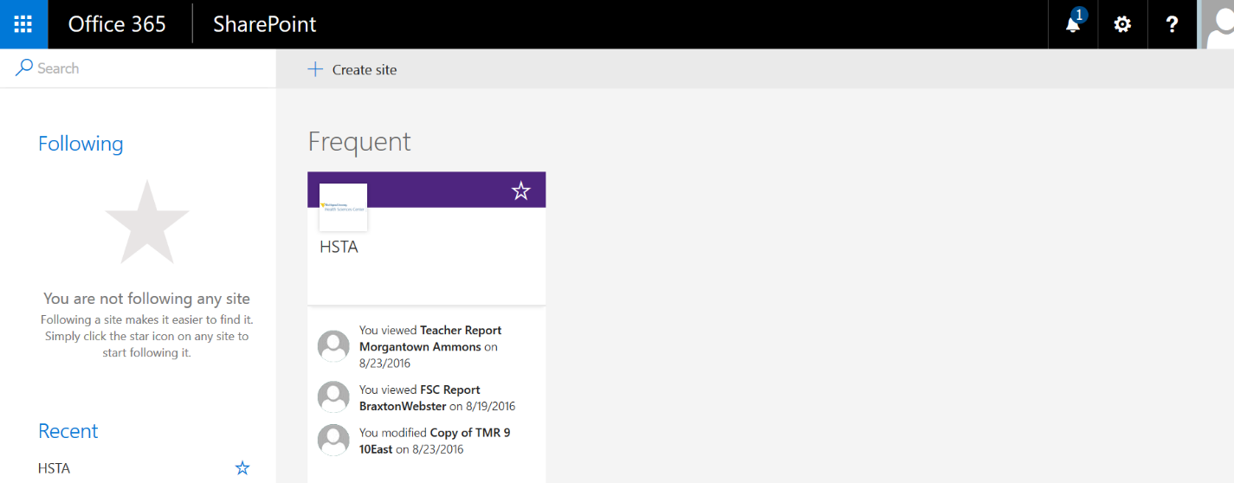

5. You will only see your region’s folder.
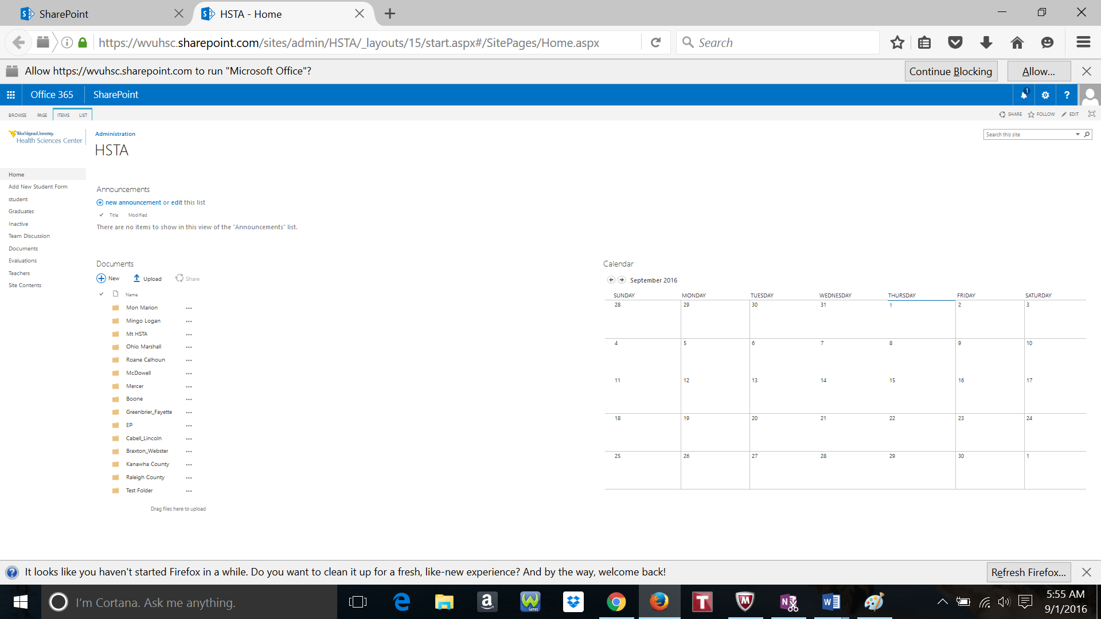

6. Click on your region’s folder. You will see Region 2014-2015, Region 2015-2016. You can review files within the folder by clicking on the folder. Edit directions start with #10.
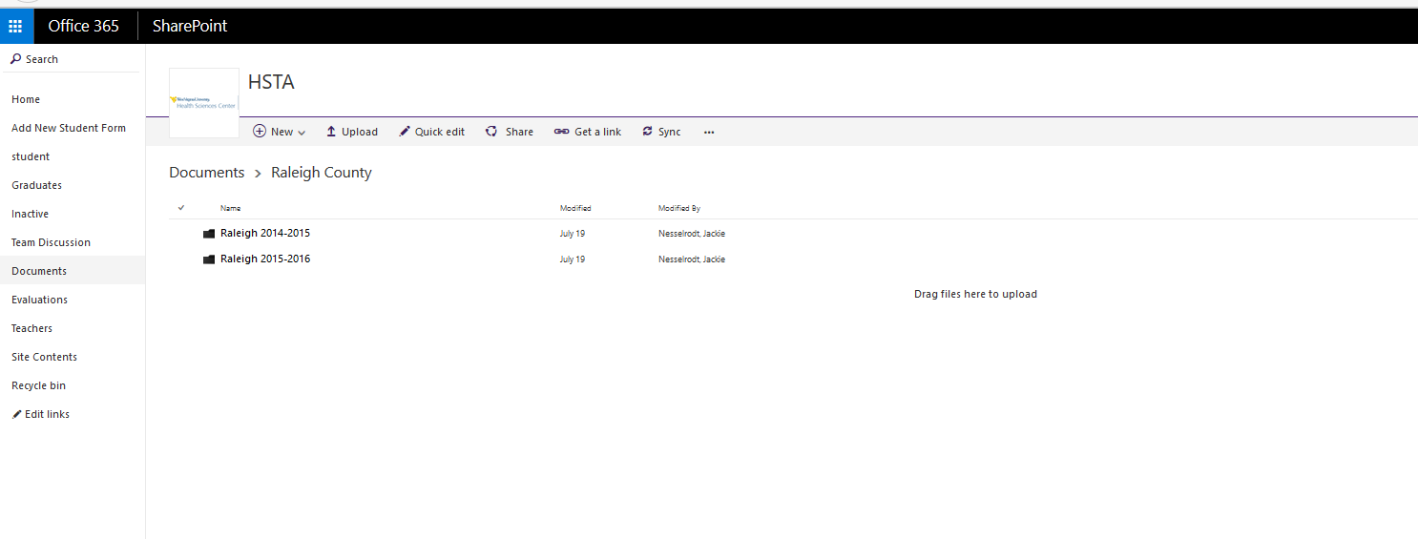
7. Adding new folder. You can add a new folder by clicking on New. You can add a new folder, word file, ETC. Once you click on the Folder – you can name it and upload files.
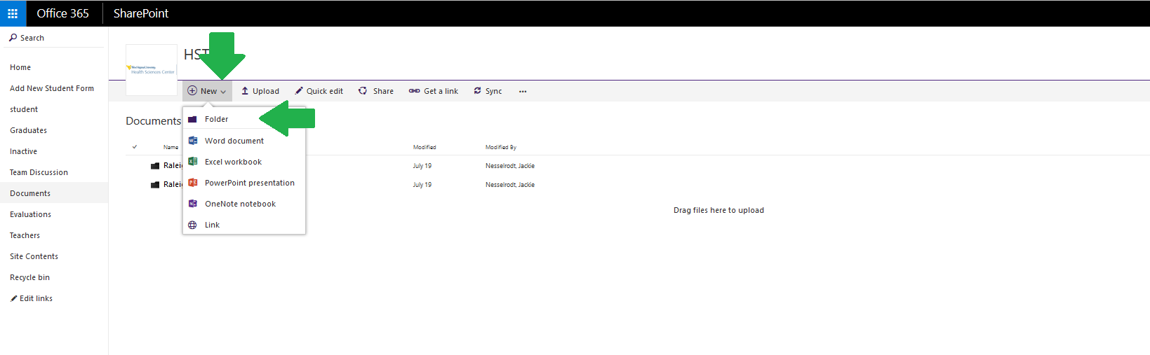
8. In the Region 2016-2017 folder only the FSC 2016-2017 report will be present. We will not move the teacher reports until late Fall/Spring.
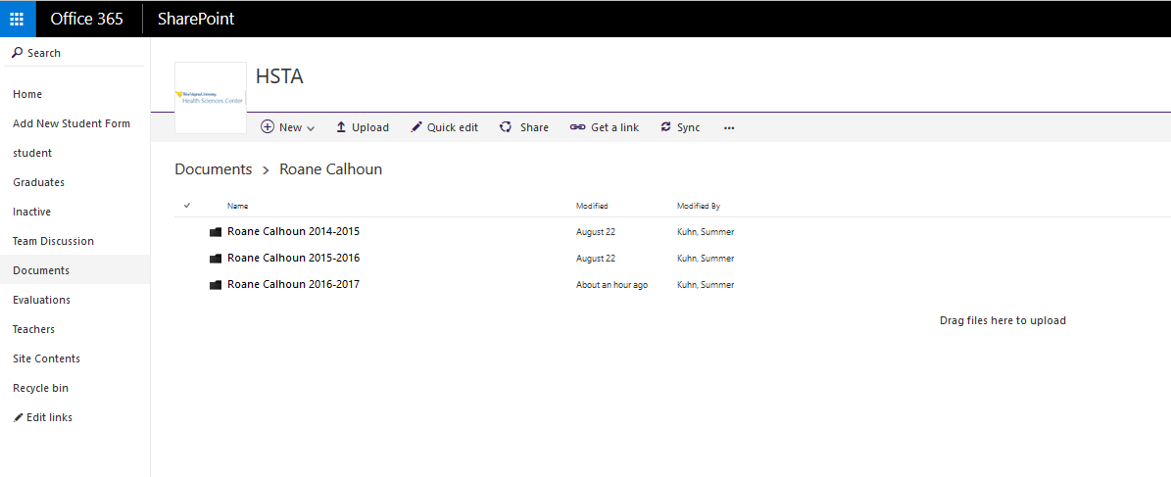
9. Uploading files. You can click on the Upload icon or you can drag material into the open space.
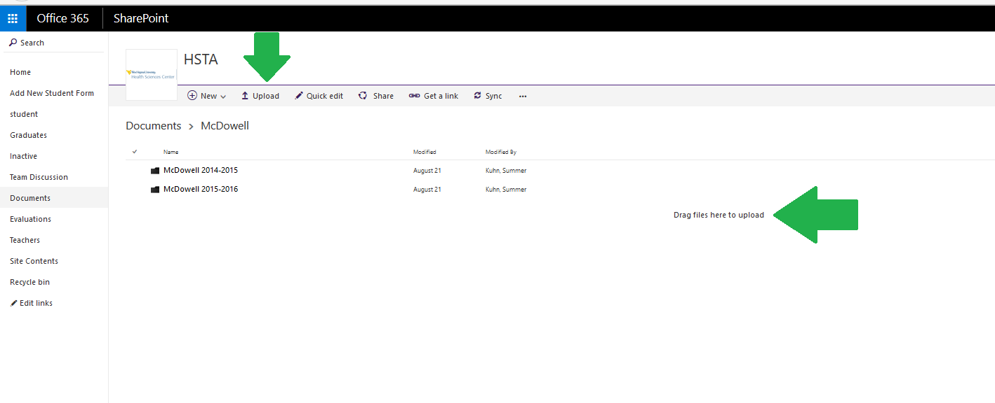
10. Once you have your material in the folder you may edit the file. You can edit one of two ways. First click on the file you want to edit. You should see the file pop up in a new tab like the example below.
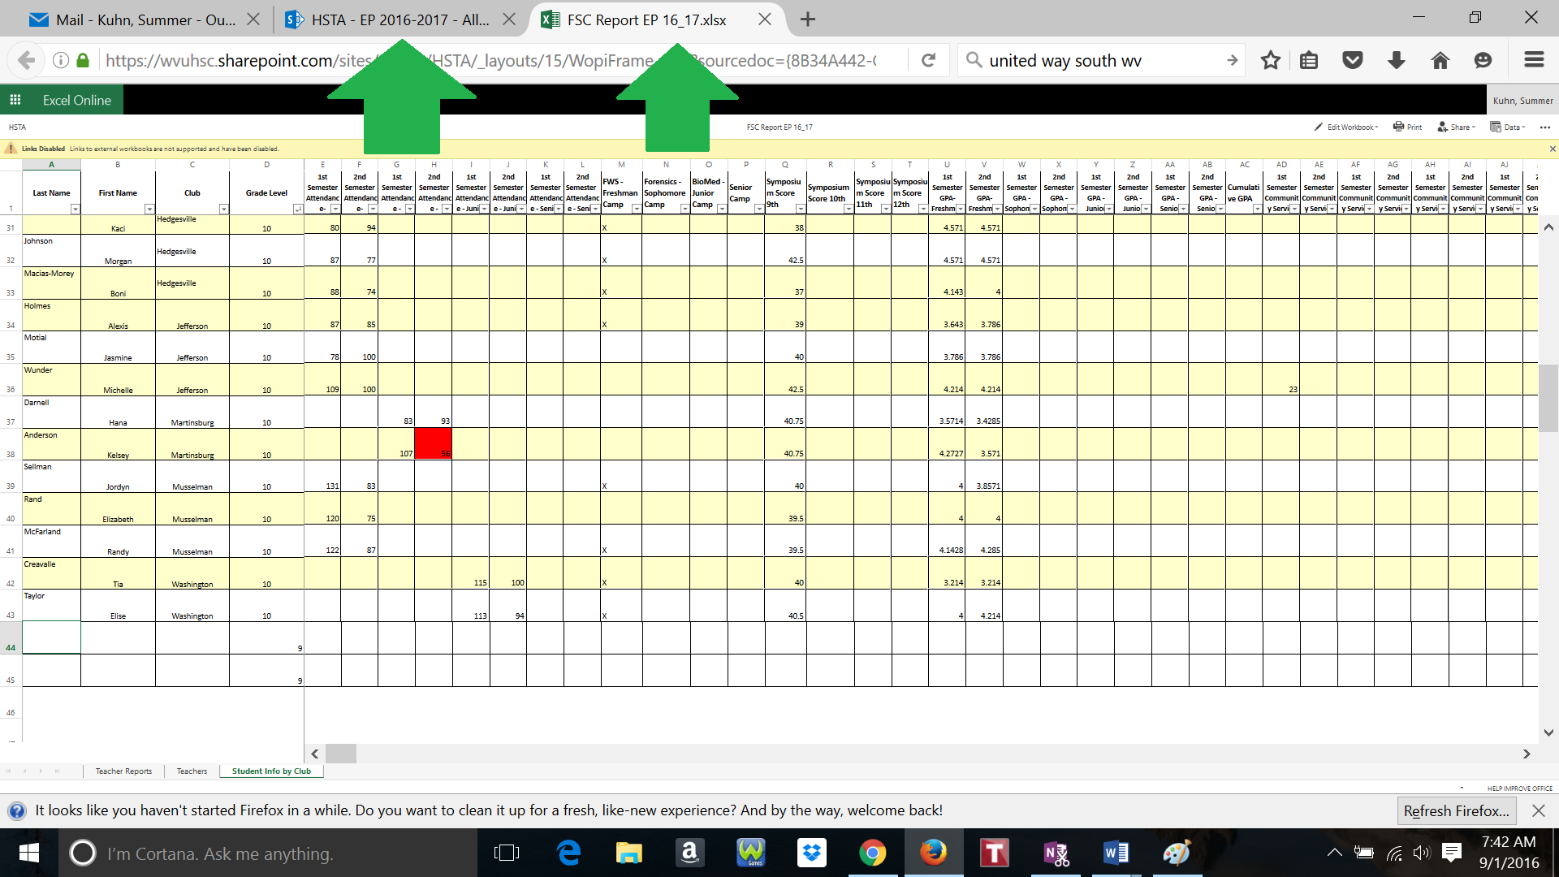

11. To edit the document click on the Edit Workbook icon. As you can see you have to options Edit in Excel and Edit in Browser. Both will allow you to edit.
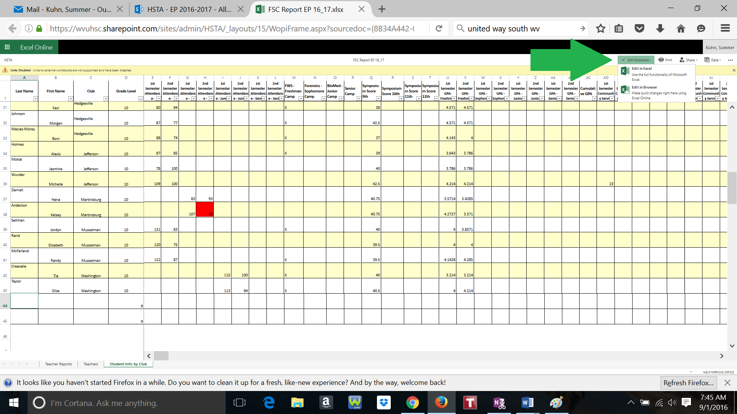
12. If you Edit in Browser you will see a similar screen. Here you don’t have full access to all of the Word icons. Make changes. To save all you have to do is click the HSTA icon to go back to the main folder. In Browser format any changes are automatically saved. Do not go to File Save As, this will create a new file. If you don’t see your changes immediately please refresh the page and edits will appear.

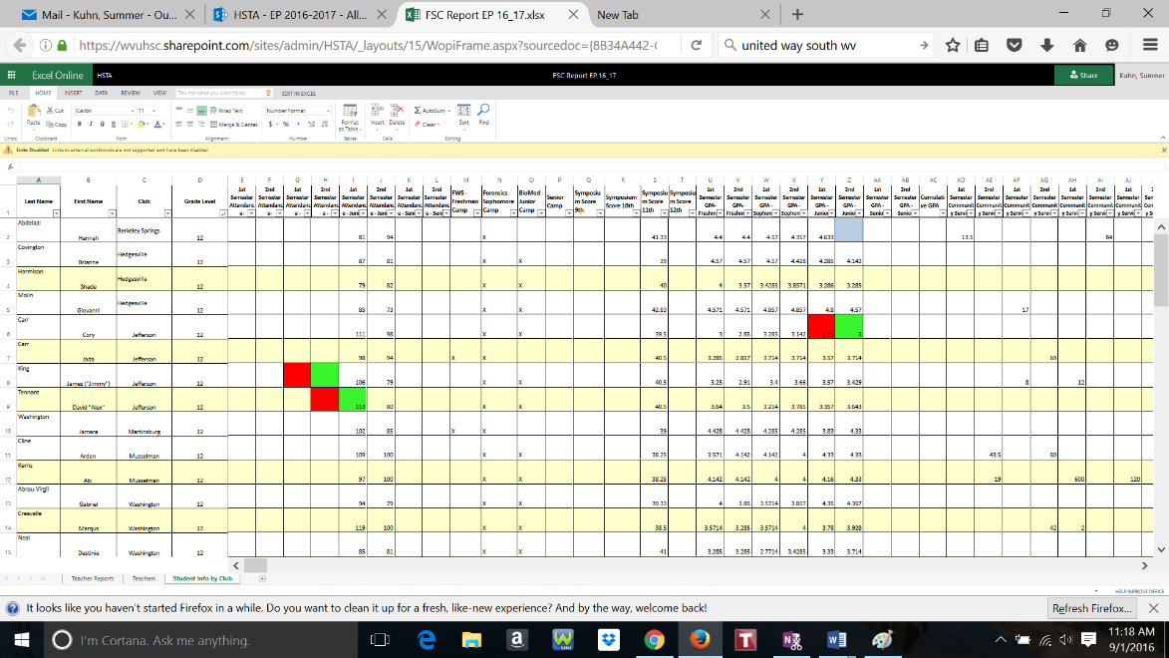
13a. Edit in Excel. Click on the Edit in Excel. It will download the file into Excel for you to edit. You may get a similar screen like the example below. Click Launch Application to use Excel.
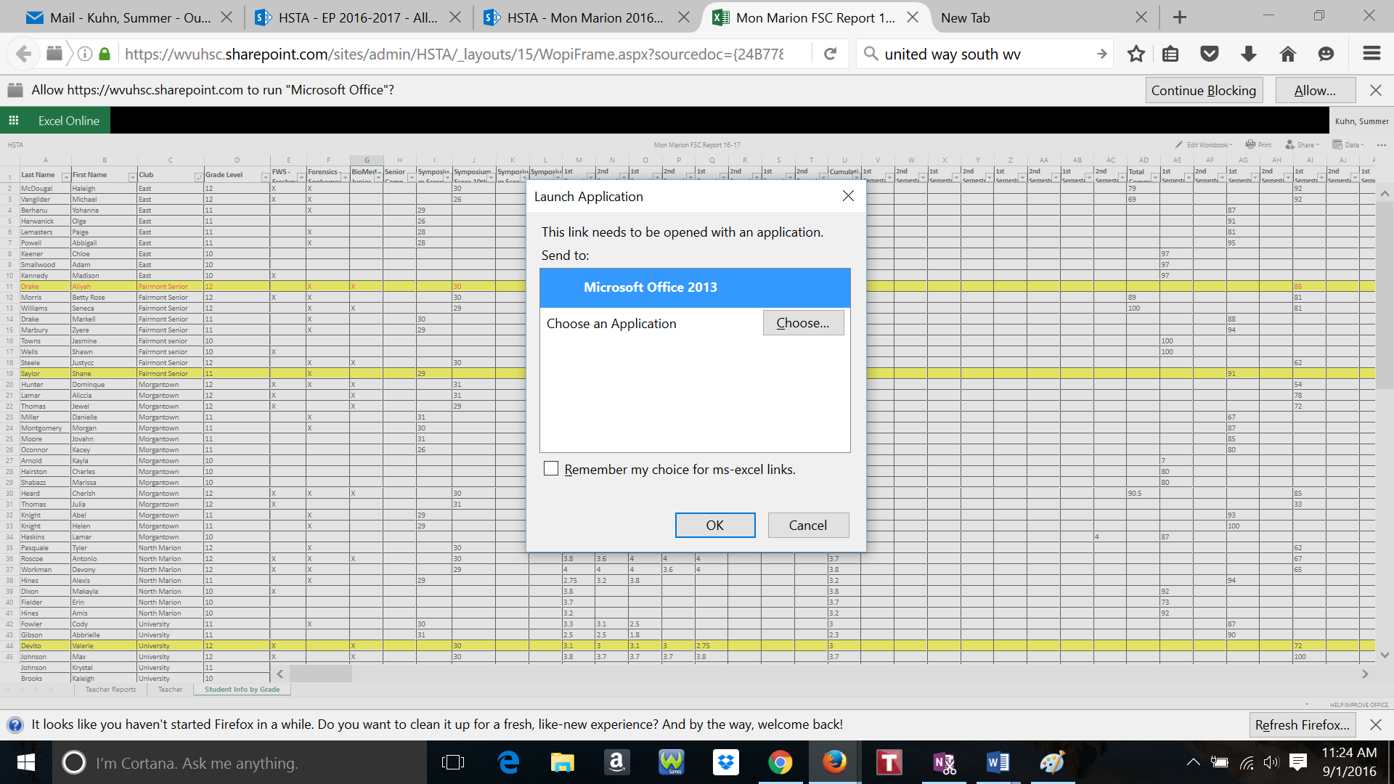
13b. You may get this second screen. If you are okay downloading the file click Yes. Remember you can also edit in Browser.
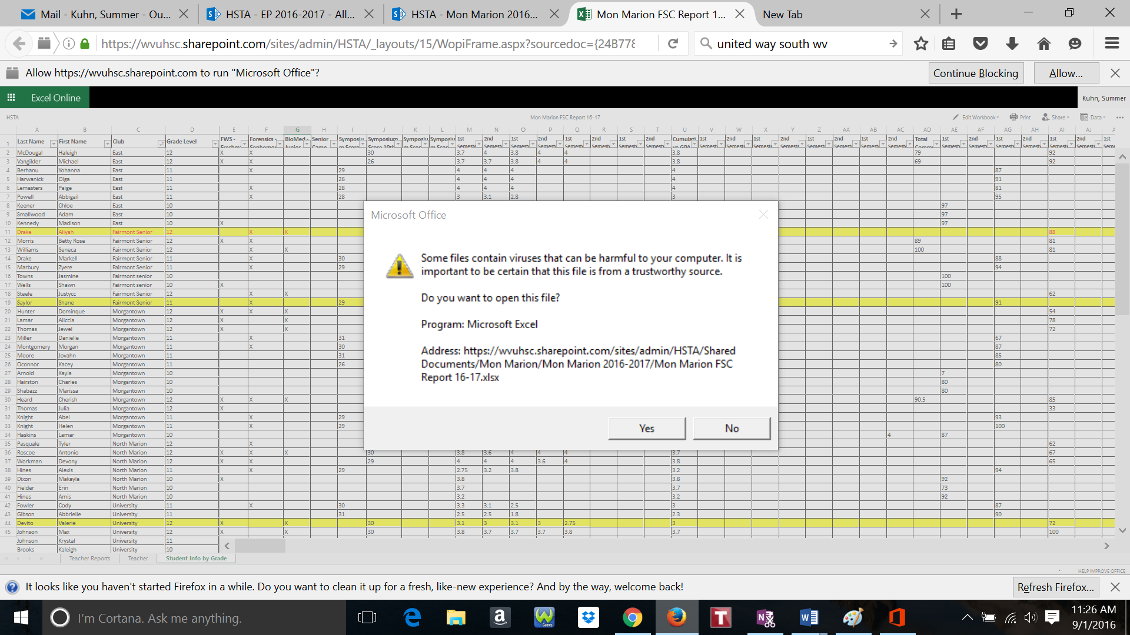
14. Once you are in excel – it should look like a normal excel sheet – make changes. Here you have to save the document by going to File, Save. Then you can close the file. It will automatically upload to SharePoint. Again if the edits do not show, refresh the page.
15. Please let me know what else would be helpful to have notes on.

